TEST PLAN DOCUMENT
Project: facebook Registration Form (Instance)
Prepared By: HARI KRISHNA
Date: November 19, 2025

Test Strategy
The strategy focuses on validating all core functionalities of the Facebook Registration workflow, including input validations, field-level errors, DOB constraints, gender selection, mobile/email verification, and account creation flow.
Testing will include:
- Functional testing of all form fields
- Negative and boundary value testing for field validations
- UI/UX and usability checks
- Compatibility across browsers and devices
- Verification of OTP/email validation flows (mocked)
- Security checks (client-side validation bypass attempts)
Both manual + exploratory testing will be performed. Regression checks will be executed upon UI/validation rule modifications.
Defects will be logged and tracked using Bugasura.

Test Objectives
• Ensure mandatory fields enforce correct validations.
• Verify proper error messages appear for invalid inputs.
• Confirm DOB restrictions (minimum age requirement = 13 years).
• Validate mobile number/email format and verification.
• Ensure gender selection works (Male/Female/Custom).
• Verify account creation successfully completes with valid data.
• Check accessibility, UI consistency, and responsiveness.
• Validate security: input sanitization, XSS protection, and form tampering restrictions

Scope
In-Scope:
• Registration form fields:
First Name, Surname, Mobile Number/Email, Password, DOB, Gender
• Field-level validations
• Error messages
• Age checks
• UI responsiveness & layout
• Cross-browser testing (Chrome, Firefox, Edge)
• Client-side validation checks

Out-of-Scope:

• Backend database validation
• Full login & post-registration onboarding
• CAPTCHA testing (if triggered conditionally)
• SMS/Email delivery system reliability
• Native mobile app (Android/iOS)

Test schedule
Activity | Start Date | End Date | Responsibility
Test Planning | Nov 20, 2025 | Nov 20, 2025 | SDET
Test Case Design | Nov 21, 2025 | Nov 21, 2025 | SDET
Environment Setup | Nov 21, 2025 | Nov 24, 2025 | Developer
Test Execution | Nov 24, 2025 | Nov 25, 2025 | SDET
Defect Fixing & Retesting | Nov 25, 2025 | Nov 26, 2025 | Developer & SDET
Test Closure & Reporting | Nov 26, 2025 | Nov 27, 2025 | SDET
Resources Planing:
Hari Krishna (SDET-Trainee) will perform manual testing and log defects using Bugasura

Risk Analysis
• Incorrect validation allowing invalid accounts to be created.
• Weak password validation leading to security vulnerabilities.
• DOB logic issues allowing underage users (<13 years).
• Email or number format mis-validation causing user frustration.
• UI layout breaking on small screens.
• Form bypass attempts via DOM manipulation.

BUGS
Bug ID: HAR1
Summary: Registration allows password with less than 6 characters

Detailed Description:-
The registration form allows users to set passwords with fewer than six characters, breaching the system's password policy constraints.
Steps To Reproduce
1. Navigate to the password change or creation screen.
2. Enter '1234567' as the new password.
3. Attempt to submit the password change or creation form.
4. Observe that the form is accepted despite the password length restriction.
Impact:-
Allows users to create weak passwords, introducing potential security vulnerabilities and risks.
Expected Behaviour:-
The system should reject passwords with fewer than six characters and display an appropriate error message.
Severity: High
Priority: P2
Environment Details:
OS: Windows 10
Browser: Chrome v142
App Version: v1.0

Bug ID: HAR2
Summary: Email field allows invalid format without “@”

Detailed Description:-
The email input field in the user registration form accepts invalid email formats such as 'user@@domain..com', which should be rejected.

Steps To Reproduce
1. Navigate to the user registration or login page.
2. Enter 'user@@domain..com' in the email input field.
3. Submit the form.
Impact:-
Allows submission of invalid email addresses, leading to potential communication issues and user account creation problems.
Expected Behaviour:-
The system should validate the email input and display an error message when an invalid format is detected.
Severity: High
Priority: P1
Environment Details:
OS: Windows 10
Browser: Chrome v142
App Version: v1.0

Bug ID: HAR3
Summary: DOB field accepts users younger than 13
Detailed Description:-
The registration form in the HARI application allows users to register with a date of birth that suggests they are under 13 years old. This violates age restrictions and allows users who do not meet the age requirement to register.
Steps To Reproduce
1. Navigate to the HARI application's user registration page
2. Enter '2008-01-01' in the date of birth field
3. Submit the registration form
4. Observe the system accepting the registration without age verification error
Impact:-
Permits underage users to register, potentially violating legal requirements and posing risks related to child protection policies.
Expected Behaviour:-
The system should display an error message and prevent registration for users whose date of birth indicates they are under 13 years old..
Severity: High
Priority: P2
Environment Details:
OS: Windows 10
Browser: Chrome v142
App Version: v1.0

Functional Test Cases
Test Case ID | Test Scenario | Test Steps | Acceptance Criteria
TES1 | Successful registration with valid details | - Open the registration page.  - Enter 'user@example.com' in the email field.  - Enter 'ValidPassword123!' in the password field.  - Enter 'ValidPassword123!' in the confirm password field.  - Enter 'John' in the first name field.  - Enter 'Doe' in the last name field.  - Submit the registration form. | Upon submission, the user receives a confirmation message indicating successful registration and the system updates to include the new account details without errors.
TES2 | Validate first name & surname fields | - Navigate to the user registration page.  - Enter 'John' in the first name field and 'Doe' in the surname field.  - Submit the form and observe if the submission is successful.  - Enter 'Ana-María' in the first name field and 'O'Neill' in the surname field.  - Submit the form and observe if the submission is successful.  - Enter 'John123' in the first name field and 'Doe@!' in the surname field.  - Submit the form and verify the presence of appropriate error messages. | The system should accept valid names with letters and certain special characters. Error messages should appear for invalid inputs such as numbers or unsupported symbols.
TES3 | Email registration | - Navigate to the registration page.  - Enter 'testuser@example.com' in the email field.  - Enter 'SecurePa$$123' in the password field.  - Enter 'testuser1' in the username field.  - Click the 'Register' button.  - Check inbox for a confirmation email.  - Click the confirmation link in the received email. | The user should receive a confirmation email and be able to confirm the account. No duplicate accounts should be created for the same email.
TES4 | Mobile number registration | - Navigate to the registration page on the HARI platform.  - Enter a valid mobile number in the designated field.  - Submit the registration form.  - Observe the system's response and any prompt for additional actions (such as OTP verification). | The system should accept the mobile number if it is in a valid format and not already registered. An OTP should be sent for verification, and upon successful entry, user registration should be completed without errors.
TES5 | Gender selection | - Log into the application with valid credentials.  - Navigate to the user profile page.  - Locate the gender selection section.  - Select a gender option (e.g., Male).  - Save the changes.  - Revisit the profile page to verify the selection is retained. | The gender selection should be visible, selectable, and must save successfully. The selected option should persist upon revisiting the profile page

Negative Test Cases
Test Case ID | Test Scenario | Test Steps | Acceptance Criteria
TES6 | Missing mandatory fields | - Navigate to the form page.  - Leave the 'username' and 'email' fields blank.  - Enter 'examplePassword123' in the 'password' field.  - Click the 'Submit' button. | The system should display an error message indicating the missing mandatory fields and prevent the form submission.
TES7 | Invalid email format | - Navigate to the user registration or login page.  - Enter 'user@@domain..com' in the email input field.  - Submit the form. | The system displays a clear error message indicating the email format is invalid and prevents the form from submitting successfully.
TES8 | Invalid mobile number | - Open the HARI application.  - Navigate to the registration form.  - Enter +12345ABC in the mobile number field.  - Submit the registration form. | When the user submits an invalid mobile number, an error message stating 'Please enter a valid mobile number.' is displayed, preventing form submission.
TES9 | Weak password | - Navigate to the application’s login page.  - Click on 'Forgot Password' or 'Create Account'.  - Enter a new password in the password field that is considered weak (e.g., '12345').  - Submit the password form. | The application should display an error message indicating that the password is too weak and provide guidance on creating a stronger password.
TES10 | Underage registration | - Navigate to the user registration page.  - Input 'testUser' into the username field.  - Input 'test@example.com' into the email field.  - Input 'SecurePass123!' into the password field.  - Input '2010-01-01' into the birthdate field.  - Submit the registration form. | Registration should be blocked. A message indicating that users must be of a certain age should be displayed to the user.

Boundary Test Cases
Test Case ID | Test Scenario | Test Steps | Acceptance Criteria
TES11 | Password min length | - Navigate to the password change or creation screen.  - Enter '1234567' as the new password.  - Attempt to submit the password change or creation form. | The system should reject the password with an error message indicating that the password must be at least 8 characters long.
TES12 | Password max limit | - Open the application and navigate to the account creation or password change page.  - Enter a password that exceeds the maximum character limit into the password field.  - Submit the form containing the excessive password length input. | The system should display an error message indicating the password exceeds the maximum length. The submission should be rejected, and the user should remain on the same page with an indication to correct the input.
TES13 | DOB lowest acceptable age | - Navigate to the HARI application's user registration page.  - Enter '2008-01-01' in the date of birth field.  - Submit the registration form.  - Observe the system response or message. | The system should display an error message indicating the user does not meet the minimum age requirement and should prevent the registration process from continuing.
TES14 | Name field max length | - Open the application and navigate to the user registration form.  - Locate the name input field.  - Attempt to enter a string that exceeds the maximum length (256 characters).  - Observe the system's response. | The name field should not accept more than the specified maximum number of characters, and an error message should be displayed or input should be truncated.
TES15 | Mobile number max digits | - Navigate to the user registration page of the HARI application.  - Locate the mobile number input field.  - Enter a valid mobile number with the exact maximum allowed digits in the input field.  - Attempt to enter additional digits beyond the maximum allowed and observe the behavior. | The mobile number field should prevent the entry of digits beyond the specified maximum. An error message or visual indication may appear to inform users of the digit restriction.

Usability Test Cases
Test Case ID | Test Scenario | Test Steps | Acceptance Criteria
TES16 | Form alignment & readability | - Open the application in a supported web browser.  - Navigate to the form page.  - Observe the alignment of input fields, labels, and buttons.  - Verify that text is readable and the elements do not overlap.  - Resize the window or use developer tools to change the resolution and repeat the observation. | All form elements must be correctly aligned, and text must be legible across different screen sizes and resolutions. There must be no overlaps or misalignments affecting readability and usability.
TES17 | Error message clarity | - Log in to the application with valid credentials.  - Navigate to the form submission page.  - Enter invalid data into the input field.  - Trigger the error by clicking the 'Submit' button. | The error message should clearly state the issue, suggest corrective actions, and be free of technical jargon. It should guide the user to rectify the error without additional assistance.
TES 18 | Keyboard navigation | - Open the HARI application.  - Use the Tab key to move focus to the first interactive element.  - Continue using the Tab key to navigate through all interactive elements.  - Use Shift + Tab to navigate backwards through elements.  - Press Enter on a focused button or link to activate it.  - Use arrow keys to navigate dropdown menus if available. | The user can navigate through all interactive elements and perform actions using only the keyboard. No element should be skipped, and all expected actions should trigger upon key presses.
TES 19 | Responsiveness | - Open the application on a mobile device with a resolution of 480x320.  - Observe the page load time and element alignment.  - Resize the browser to simulate different screen widths.  - Check if elements adapt fluidly without overlapping.  - Access the application via tablet with resolution 1280x800 and repeat the observations.  - Access the application via desktop with resolution 1920x1080 and repeat the observations. | The application loads within 2 seconds, the interface adapts to different resolutions without layout issues, and navigation remains smooth across devices.
TES 20 | Gender custom option usability | - Navigate to the user profile settings page.  - Locate the gender selection component.  - Select 'Custom' from the gender options.  - Enter 'Non-binary' in the custom text input field.  - Save the changes.  - Verify the saved gender value displays as 'Non-binary' on the profile page. | The system should allow the user to select 'Custom' gender and enter a non-predefined value. The custom value should be visibly displayed on the user's profile after saving.

BUG-HAR1

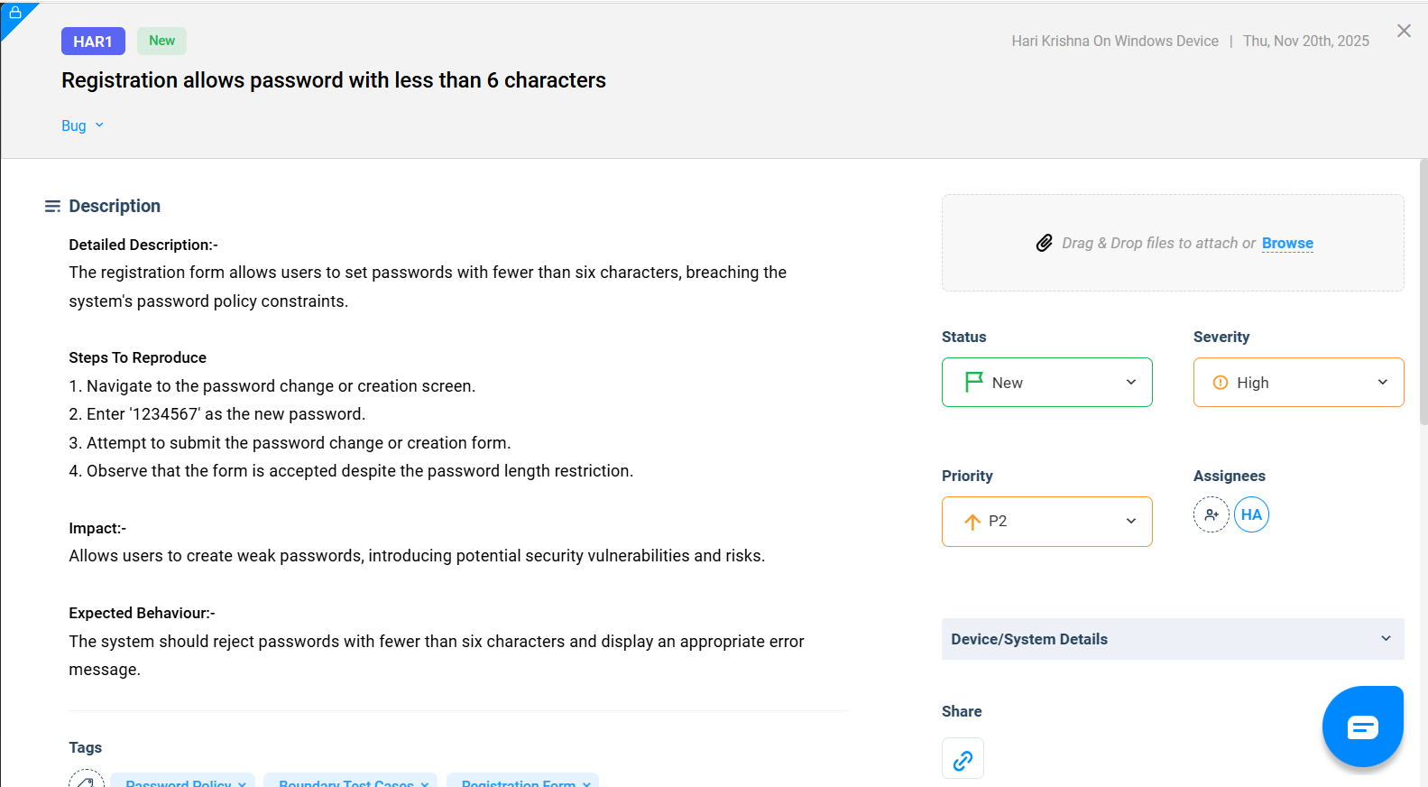

BUG-HAR2

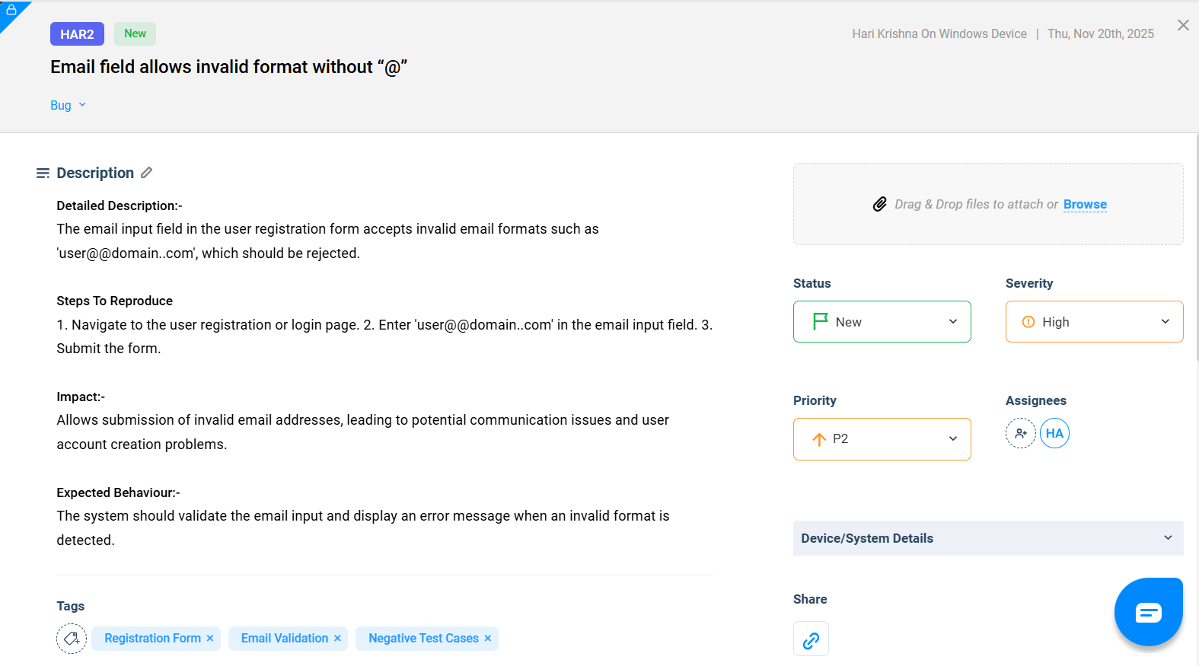

BUG-HAR3

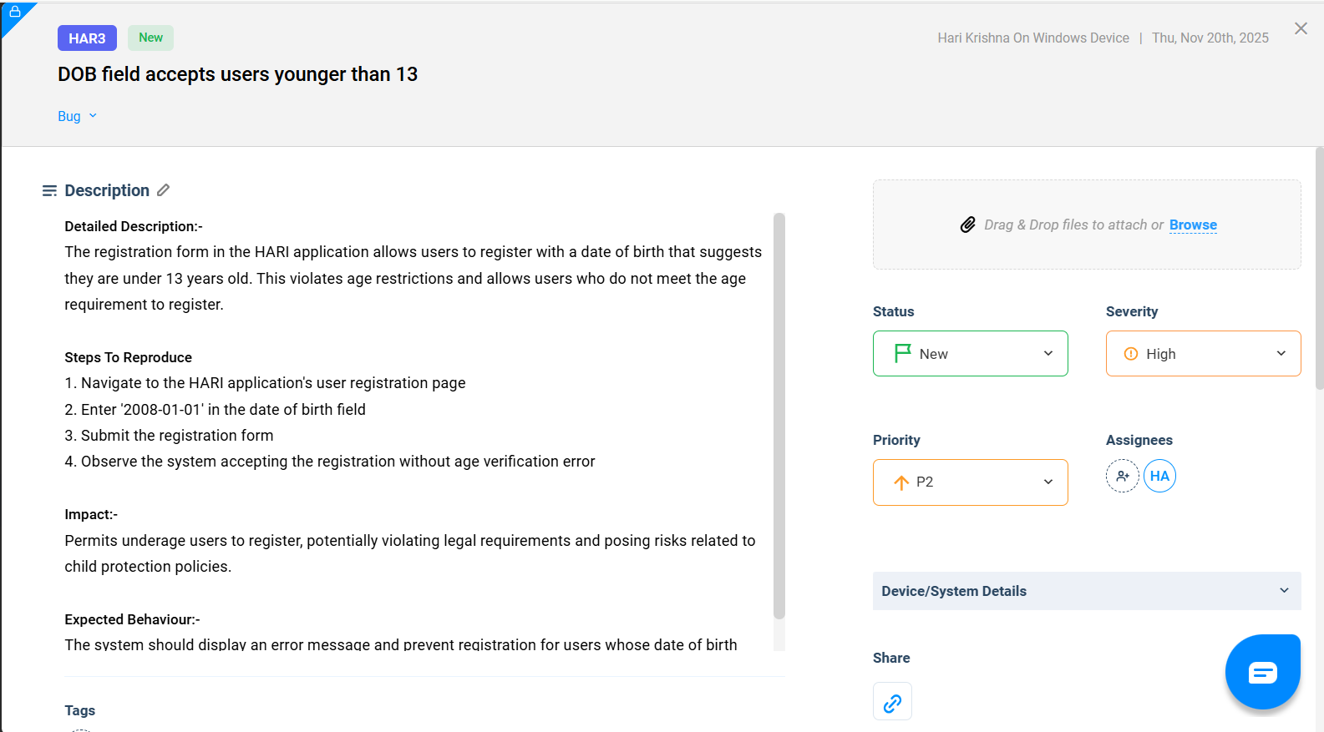

TEST CASE TEMPLATE
Test Case ID | :TES10
Title | : Underage registration
Module | :Registration From- Age Validation
Pre-conditions | :https://www.facebook.com/reg/  (NOTE: I’M USING THIS ONE FOR AN INSTANCE)
Test Steps | - Navigate to the user registration page.  - Input 'testUser' into the username field.  - Input 'test@example.com' into the email field.  - Input 'SecurePass123!' into the password field.  - Input '2010-01-01' into the birthdate field.  Submit the registration form
Test Data | : Date of Birth :- 05 Nov 2019  Other Fields:- Valid Inputs
Expected Result | : It will show “You must be at least 13 years old” error
Post-conditions (optional) | -----
Priority | : High
Type (Functional/Negative/Boundary/etc.) | : Negative
Status | :In Process

